Theme 8

World War I: To Play or Not to Play?

Pupil Resource Sheet

Roland Hely Owen

Huddersfield Old Boys
Rugby Union Football Club
Roland Owen was an army officer in the 2nd Duke of Wellington’s West Riding Regiment, captain of Huddersfield Old Boys Rugby Union Football Club and a Yorkshire county rugby union footballer.

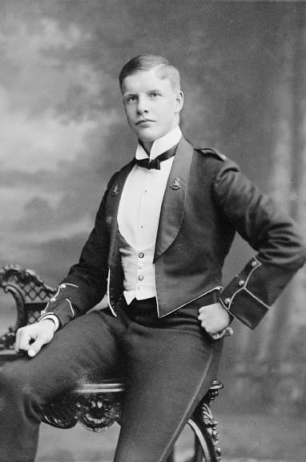
Roland Hely Owen

By the end of September 1914, less than two months after war was declared, eighteen of the Huddersfield Old Boys’ players were serving in the armed forces. The club was forced to abandon all its fixtures until the war was over.
Roland Owen’s Letter
In November 1914 Roland Owen wrote a letter to the secretary of the Huddersfield Old Boys club. Roland was clearly annoyed and frustrated at the number of sportsmen who had not volunteered to join the armed forces:

‘This was going to be our great year. Well, so it will be if we send as many on to the field of battle as we send on to the field of play.’

The Weekly Dispatch’s Picture
The secretary sent Roland’s letter to a national newspaper, the Weekly Dispatch. One of the journalists was inspired by Roland’s comments, and on 22 November 1914 the Weekly Dispatch printed a picture of a wounded soldier standing over a fallen comrade in Flanders. The wounded soldier was looking towards a photograph of a large crowd watching the FA Cup Final at Crystal Palace.

The War Office’s Poster
The War Office adapted this picture, adding the caption ‘Will they never come?’ It became one of the most successful recruitment posters of the war.

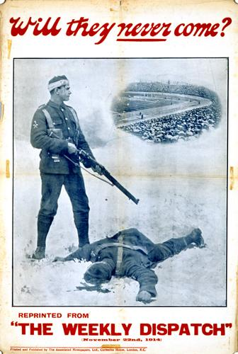

The Effects of the Poster
A good number of rugby and association footballers and supporters had already volunteered for the armed forces. In Huddersfield, although the professional clubs Huddersfield Town FC and the Huddersfield Northern Union Rugby FC continued to play, the amateur rugby and football leagues were abandoned in early November 1914 owing to a shortage of players.

After this poster was published, the numbers of volunteers from rugby and association football quickly increased across the country. It is estimated that of the first 700,000 new recruits to the army, 100,000 came from players and supporters of rugby and association football.

The Battle of Hill 60
Lieutenant Roland Owen was a brave soldier. He fought in the major battles of 1914 at Mons, Le Cateau, the Marne and the Aisne.

At 6pm on Saturday 17 April 1915 he was one of many Huddersfield lads who led the British charge of Hill 60, a small mound held by the Germans, about two and a half miles south east of Ypres.

Corporal AE Wilkinson, a tram conductor from Moldgreen, was in the platoon commanded by Lieutenant Owen. He wrote a letter about the attack.

‘… before dawn on Sunday casualties were increasing most alarmingly. During the whole of Sunday we were subjected to a most pitiless fire from all sorts of short range guns, bombs, and shells, with disastrous effect to us.’

At 5.30pm on Sunday afternoon, as the platoon sheltered in a shell crater, Lieutenant Owen called together the few officers left alive.

‘Mr Owen said we were to attack the enemy’s trenches over the crest of the craters at 6pm, making a bayonet charge and pinching a few more trenches from them ...

Mr Owen patted me on the shoulder just prior to the charge, saying as he did so, with a smile, “Well, corporal, Huddersfield’s going to see this through.” He was enough to oil anyone with courage. He was simply brimful of it. He revelled in danger … and such men inspire the less courageous. When the whistle blew, we kicked off, and put the fear of God into them, and they fled down the communications trenches – those that could get away. Mr Owen and myself were over the parapet from our crater like a shot …’

Suddenly, Corporal Wilkinson saw Lieutenant Owen ‘reel as if hit in the neck.’ A shell had burst, flooring Owen and Lance Corporal WJ Coates of Thurstonland, who ‘fell helpless on the lieutenant’s body ... “Come on, Coates, we shall have to stick it; It is going to be a warm job,”’ encouraged Owen. They were his last words.

Lance Corporal Coates was lifted from the Lieutenant’s corpse and carried from the battlefield, severely wounded. Lance Corporal Coates survived, but Lieutenant Owen was dead.

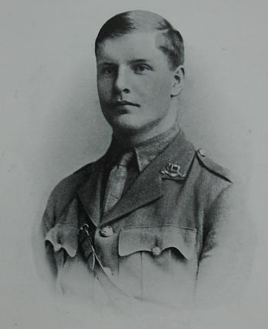
Lieutenant Roland Hely Owen (1893-1915)

Huddersfield Old Boys
Rugby Union Football Club
Of the eighteen Huddersfield Old Boys rugby footballers who went to war, six were killed. The club resumed playing matches in the spring of 1919, five months after the Armistice of 11 November 1918.

